Training Report

on
Koncept-Your Personal Ai Teacher

Submitted in partial fulfillment of the requirements
for the award of the degree of

Bachelor of Technology

in

CSE

Submitted By
Vaani Mangal
2823212
Batch (2023-2027)



Panipat Institute of Engineering & Technology,
(Affiliated to Kurukshetra University Kurukshetra, India)
Samalkha, Panipat
(Session e.g. 2025-2026)

Abstract
In recent years, artificial intelligence has significantly transformed the way information is accessed and delivered. AI-powered chatbots and virtual assistants have become widely popular due to their ability to provide fast, accurate, and context-aware responses. However, despite their effectiveness, most existing AI systems rely heavily on text-based outputs. This limitation reduces user engagement and makes it difficult for learners to fully understand complex concepts, especially those that require visual explanation or guided narration. Learning research shows that individuals grasp concepts more effectively when information is presented through a combination of text, visuals, and audio rather than text alone. This gap between AI-generated information and effective learning methods forms the core motivation behind this project.

The purpose of this project, titled “Koncept – Your Personal AI Teacher,” is to design and develop an AI-driven multimedia content generation system that converts user queries into complete video-based learning material. The main objective is to overcome the shortcomings of traditional text-only AI chatbots by delivering content in an engaging, accessible, and learner-friendly multimedia format. Koncept aims to simplify the process of educational content creation while improving understanding, retention, and accessibility for users with diverse learning preferences.

Koncept works by accepting a topic or question as input from the user. The system then uses a Large Language Model (LLM) to analyze the query and generate accurate, structured, and relevant content. Instead of presenting the output as plain text, the generated content is intelligently divided into meaningful sections and formatted into slide-ready points. These points are then used to automatically create a PowerPoint presentation, ensuring logical flow, clarity, and readability.

To enhance learning further, the system integrates Text-to-Speech (TTS) technology to generate audio narration corresponding to each slide. The narration explains the slide content in simple and understandable language, making the system suitable for a wide audience, including students, teachers, and professionals. The slides and narration are synchronized and finally combined into a single video file. This video-based output allows users to learn visually and audibly, closely simulating the experience of a personal teacher.

The development of Koncept follows the principles of Multimedia Learning Theory, which states that people learn better when information is presented using both visual and auditory channels. Additionally, the project is designed according to Universal Design for Learning (UDL) guidelines, ensuring inclusivity and accessibility. Audio narration supports learners with reading difficulties, while structured slides assist visual learners. By breaking complex topics into smaller segments, the system also reduces cognitive load and improves comprehension.

Through the implementation of this project, valuable insights were gained regarding AI-based content generation, natural language processing, multimedia integration, and automation. The project demonstrates how artificial intelligence can be effectively used not only to answer questions but also to deliver knowledge in a more human-like and pedagogically sound manner. It also highlights the potential of AI systems to reduce the manual effort required in preparing presentations, voiceovers, and educational videos.

In conclusion, Koncept – Your Personal AI Teacher successfully addresses the limitations of text-based AI systems by providing an automated solution for multimedia content generation. By transforming simple user inputs into structured presentations with synchronized audio and video output, the system enhances engagement, understanding, and accessibility. Koncept has strong potential applications in education, corporate training, online learning platforms, and professional communication. The project demonstrates that AI-driven multimedia learning tools can play a significant role in shaping the future of education and knowledge sharing.

Abbreviations

AI | Artificial Intelligence
LLM | Large Language Model
NLP | Natural Language Processing
TTS | Text-to-Speech
PPT | PowerPoint Presentation
API | Application Programming Interface
UDL | Universal Design for Learning
UI | User Interface
UX | User Experience
CPU | Central Processing Unit
RAM | Random Access Memory
IDE | Integrated Development Environment
UML | Unified Modeling Language
DFD | Data Flow Diagram
ER | Entity Relationship
PDF | Portable Document Format
GUI | Graphical User Interface
OS | Operating System
ML | Machine Learning
AV | Audio-Visual

CONTENTs

Candidate's Declaration i

Certificate ii
Acknowledgement iii
Abstract iv

List of Figures v

List of Tables vi
Abbreviations viii

CHAPTER NO DESCRIPTION PAGE NO.

Chapter 1: INTRODUCTION 1

1.1 Overview of the Project 1

1.2 Problem Statement 4
1.3 Objectives of the Project 6
1.4 Scope of the project

Chapter 2: LITERATURE REVIEW 14

2.1 Introduction To Literature Review 1

2.2 Conversatioal Ai And Chatbots 4
2.3 Multimedia Learning Theory 6
2.4 Accessibility and Universal Design for Learning 7

2.5 Automated Presentation Generation Systems 1

2.6 Text-To-Speech(TTS) 4
2.7 Limitation Of Existing System 6
2.8 Research Gaps And Novelty

2.9 Summary 1

Chapter 3: SOFTWARE AND HARDWARE REQUIREMENT 1

1.1 Software Requirement 1

1.2 Hardware Requirement 4

Chapter 1: SOFTWARE DESIGN 1

1.1 Introduction 1

1.2 System Architecture 4
1.3 Module Wise Design Description 6
1.4 UML Diagram

1.1 Data Flow Diagram 1

1.2 Design Advantages 4
1.3 Summary 6

Chapter 1: TESTING 1

1.1 Introduction of the Testing 1

1.2 Objective of the Testing 4
1.3 Testing Strategy 6
1.4 Black Box Testing

1.1 White Box Testing 1

1.2 Integration Testing 4
1.3 Performance Testing 6

1.1 Error Handling And Validation 1

1.2 Testing Environment 4
1.3 Summary 6

Chapter 1: OUTPUT SCREENS 1

1.1 User Input Interface 1

1.2 Ai Generated Test Response 4
1.3 Structure Slide Content Output 6

1.1 PPT Generation Output 1

1.2 Audio Naration Output 4
1.3 Video Generation Output 6

Chapter 1: CONCLUSION 1

Chapter 1: FUTURE ENHANCEMENT AND RECOMMENDATIONS 1

Chapter 1: REFERENCE

CHAPTER 1: INTRODUCTION
1.1 Overview Of The Project
Artificial Intelligence (AI) has revolutionized the way humans interact with technology by enabling machines to simulate human intelligence and perform tasks such as reasoning, learning, problem-solving, and language understanding. Over the past decade, AI has become an integral part of daily life, influencing areas such as education, healthcare, finance, entertainment, and professional work environments. Among the various applications of AI, chatbots and Large Language Models (LLMs) have gained widespread popularity due to their ability to understand natural language and provide quick, accurate, and context-aware responses.
AI-powered chatbots are now commonly used by students for academic support, by teachers for content generation, and by professionals for documentation, research, and decision-making assistance. These systems offer several advantages, including instant availability, scalability, and cost-effectiveness. However, despite their growing adoption and intelligence, most AI chatbots still rely heavily on text-based interaction. While text is an effective medium for conveying information, it is not always sufficient for deep understanding, especially when dealing with complex concepts, technical subjects, or instructional content.
Educational research has shown that learners comprehend and retain information more effectively when it is presented through multiple modes such as text, visuals, and audio. Text-only explanations may lead to reduced engagement, cognitive overload, and difficulty in understanding abstract ideas. Visual elements such as slides, diagrams, and structured bullet points help organize information, while audio narration supports auditory learners and improves accessibility. Therefore, relying solely on text limits the overall effectiveness of AI-based learning tools.
Koncept – Your Personal AI Teacher is developed to address this limitation by transforming traditional text-based AI responses into complete multimedia learning resources. Instead of displaying plain text answers, Koncept automatically converts user queries into well-structured PowerPoint presentations accompanied by synchronized audio narration. The system then merges the slides and narration into a video format, providing users with a ready-to-use multimedia presentation.
The primary goal of Koncept is to simulate the experience of learning from a personal teacher by combining AI intelligence with multimedia presentation techniques. This approach makes learning more engaging, interactive, and accessible to a wider audience. By automating the entire process of content generation, slide creation, narration, and video production, Koncept significantly reduces manual effort and enhances productivity for students, educators, and professionals.

1.2 Problem Statement
Despite rapid advancements in Artificial Intelligence and Natural Language Processing, existing AI chatbots exhibit several limitations that restrict their effectiveness as complete educational and professional tools. The major problems identified in current systems are outlined below.
Firstly, most AI chatbots generate text-only outputs. While these outputs may be informative and accurate, long textual explanations often become monotonous and difficult to follow. Users may lose interest, especially when learning complex topics that require visual support and guided explanation.
Secondly, current AI systems offer low engagement and interactivity for extended learning sessions. Text-based responses do not actively involve users in the learning process and fail to provide a classroom-like experience. This reduces motivation and learning effectiveness.
Thirdly, existing chatbots are not suitable for users with reading difficulties or visual impairments. Text-heavy content creates accessibility barriers for learners who rely on audio-based learning or structured visual presentation. The lack of inclusive design limits the usability of AI tools for a diverse population.
Another major issue is that users must manually convert AI-generated text into PowerPoint slides and audio narration. This process requires additional time, technical skills, and effort. Students, teachers, and professionals often face time constraints and may not have the resources to prepare high-quality multimedia presentations manually.
Finally, the overall process of preparing presentation-ready content using current tools is time-consuming and inefficient, especially when content needs to be generated repeatedly for different audiences or purposes.
Due to these limitations, there is a strong need for an intelligent AI-based system that can automatically generate ready-to-use multimedia presentations, including structured slides and voice narration, directly from user input. Such a system would enhance engagement, improve accessibility, and reduce manual effort, thereby making AI more practical and effective for real-world learning and communication.

1.3 Objectives of the Project
The primary objective of the Koncept project is to design and implement an AI-driven system that goes beyond text-based responses and delivers knowledge in a multimedia format. The specific objectives of the project are as follows:
- To develop an intelligent AI chatbot capable of producing multimedia output instead of plain text.
- To automatically generate well-structured PowerPoint slides from AI-generated textual content.
- To convert slide content into clear, natural, and understandable voice narration using Text-to-Speech technology.
- To synchronize slides and narration and merge them into a complete video presentation.
- To enhance user engagement by combining visual and auditory learning methods.
- To improve accessibility for visually impaired users and individuals with reading difficulties.
- To reduce the manual effort, time, and technical skills required for content preparation.
- To provide a scalable and efficient solution for educational and professional content generation.
These objectives aim to transform AI chatbots from simple question-answering systems into comprehensive digital teaching assistants capable of delivering knowledge in an effective and learner-friendly manner.
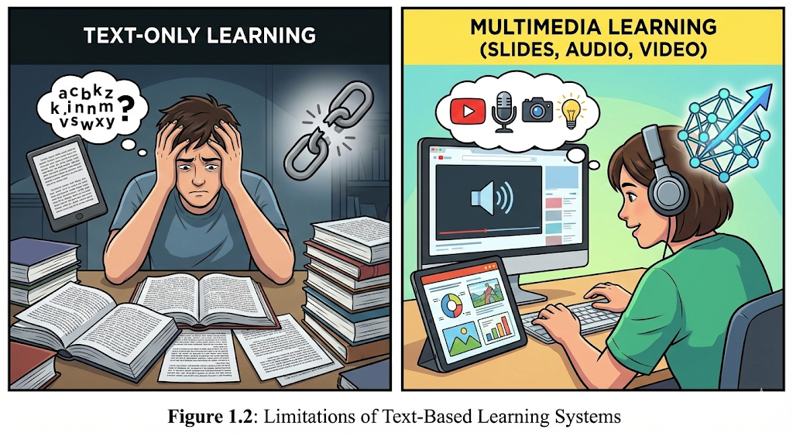

1.4 Scope of the Project

The scope of the Koncept project defines the boundaries, applicability, and functional coverage of the system. The project focuses on integrating artificial intelligence with multimedia generation to enhance learning and presentation experiences. The scope includes the following aspects:
- Generation of educational and informational content based on user-provided queries or topics.
- Automated creation of PowerPoint presentations with logically organized slides.
- Integration of Text-to-Speech technology for audio narration of slide content.
- Generation of video output by combining slides and narration into a single multimedia file.
- Support for students, teachers, trainers, and professionals across various domains.
- Application in classrooms, online learning platforms, seminars, training sessions, meetings, and presentations.
- Promotion of accessibility and inclusive learning for visually impaired and reading-challenged users.
The project primarily focuses on functionality, automation, and learning effectiveness rather than advanced graphic design or animation. Koncept is intended to serve as a practical and scalable solution for multimedia content generation in educational and professional environments.

CHAPTER 2 – LITERATURE REVIEW

2.1 Introduction to Literature Review

The literature review provides a comprehensive study of existing research, technologies, and systems related to conversational artificial intelligence, multimedia learning, text-to-speech systems, and automated presentation generation. The purpose of this chapter is to analyze previous work, identify strengths and limitations of existing approaches, and highlight research gaps that justify the need for the proposed system, Koncept – Your Personal AI Teacher.
With the rapid advancement of AI-based chatbots and language models, the focus has primarily been on improving accuracy, fluency, and contextual understanding of text-based responses. However, limited attention has been given to transforming AI outputs into rich multimedia formats that enhance engagement and accessibility. This chapter reviews relevant studies and frameworks to establish the foundation of the proposed work.

2.2 Conversational AI and Chatbots
Conversational Artificial Intelligence has witnessed significant growth with the development of rule-based chatbots, retrieval-based systems, and more recently, generative AI models. Early chatbots such as ELIZA and ALICE relied on pattern matching and predefined rules, offering limited interaction capabilities. Although these systems demonstrated the feasibility of human-computer interaction, their responses lacked depth and adaptability.
Modern chatbots powered by Large Language Models (LLMs) have dramatically improved natural language understanding and response generation. These systems are capable of producing detailed, context-aware responses across multiple domains. However, despite these advancements, the output format of most chatbots remains predominantly text-based. This restricts their effectiveness in educational and professional contexts where visual aids and audio explanations are crucial.
Several studies highlight that text-only conversational agents often fail to maintain user engagement over long sessions. Users frequently need to copy the generated content and manually convert it into presentations, voiceovers, or videos. This additional effort reduces productivity and limits real-world adoption of AI chatbots as complete teaching or presentation tools.

2.3 Multimedia Learning Theory
Multimedia Learning Theory, proposed by Richard E. Mayer, emphasizes that learners understand and retain information more effectively when content is presented through multiple channels, particularly visual and auditory. According to this theory, humans process information through two primary channels: the visual channel and the auditory channel. Effective learning occurs when both channels are used in a balanced manner.
Mayer’s Cognitive Theory of Multimedia Learning suggests that combining text, images, and narration reduces cognitive overload and improves comprehension. Research indicates that learners exposed to multimedia content demonstrate better recall, problem-solving ability, and conceptual understanding compared to those who rely solely on textual materials.
The relevance of multimedia learning theory strongly supports the motivation behind Koncept. By converting AI-generated text into slides with synchronized narration, the proposed system aligns with established educational research. This ensures that the system is not only technologically advanced but also pedagogically effective.

2.4 Accessibility and Universal Design for Learning (UDL)
Universal Design for Learning (UDL) is an educational framework that promotes inclusive learning environments by providing multiple means of representation, engagement, and expression. According to UDL principles, learners have diverse needs and preferences, and educational content should be adaptable to accommodate these differences.
Studies have shown that students with reading difficulties, visual impairments, or learning disabilities benefit significantly from audio-supported and visual learning materials. Text-to-Speech (TTS) technologies play a vital role in improving accessibility by converting written content into spoken form. Research conducted by Wood et al. indicates that TTS systems improve reading comprehension and learning outcomes, particularly for students with learning challenges.
Despite these findings, most AI chatbots do not integrate accessibility features such as narration or multimedia output by default. Koncept addresses this gap by incorporating TTS and visual presentations, thereby supporting inclusive education and aligning with UDL guidelines.

2.5 Automated Presentation Generation Systems
Automated presentation generation is an emerging research area that aims to reduce the manual effort required to create slides and visual content. Existing tools primarily rely on templates where users must manually input content. Some AI-based tools assist in summarization or slide structuring but still require significant human intervention.
Few systems attempt to automate the entire pipeline from content generation to final presentation delivery. Moreover, most tools do not include synchronized audio narration or video export functionality. As a result, users often need to use multiple software tools to achieve a complete multimedia presentation.
The lack of a unified, end-to-end solution highlights the necessity of systems like Koncept, which integrates content generation, slide creation, audio narration, and video output into a single automated workflow.

2.6 Text-to-Speech (TTS) Technologies
Text-to-Speech technology has evolved from robotic-sounding voices to natural, human-like speech synthesis. Modern TTS systems use deep learning models that produce expressive and intelligible audio output. These advancements have made TTS suitable for educational, assistive, and professional applications.
Research shows that audio narration enhances understanding, particularly for complex topics. TTS also supports multitasking and auditory learning preferences. However, TTS is often used as a standalone tool and is rarely integrated seamlessly into AI chatbot systems for presentation generation.
Koncept leverages TTS not merely as an add-on feature but as a core component of the learning experience, ensuring synchronized narration for each slide.

2.7 Limitations of Existing Systems
From the reviewed literature, the following limitations are identified:
- Most AI chatbots provide text-only responses
- Lack of multimedia output reduces engagement
- No single system offers end-to-end automation
- Accessibility features are often missing
- Manual effort is required for slide and audio creation
These limitations create a significant gap between AI-generated content and practical real-world usage.

2.8 Research Gap and Novelty
Based on the literature review, it is evident that although conversational AI and multimedia learning technologies exist independently, their integration into a single automated system remains limited. There is no widely adopted solution that converts chatbot responses directly into presentation-ready multimedia content.
The novelty of Koncept lies in its end-to-end automation pipeline that transforms user input into structured slides, adds audio narration, and generates a final video presentation. This approach not only enhances engagement but also improves accessibility and usability.
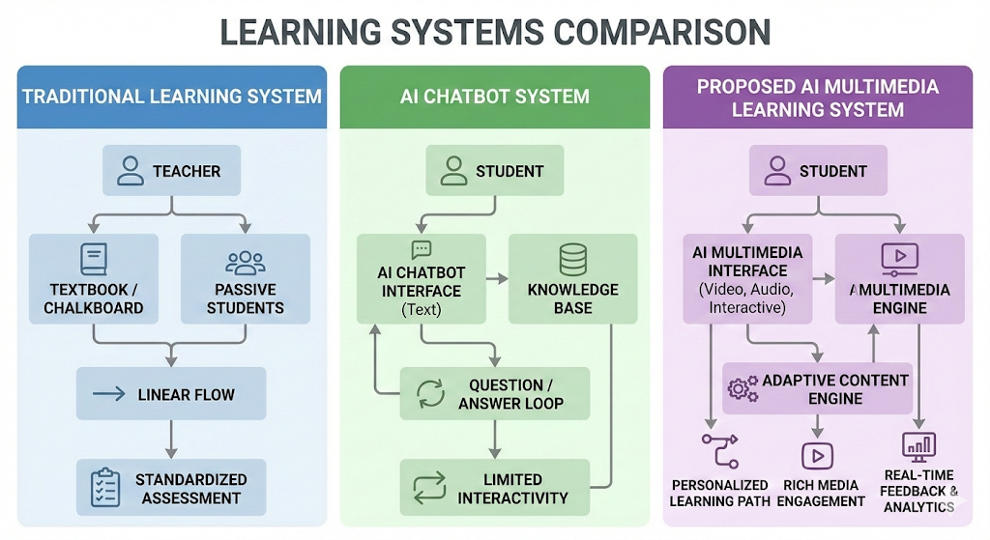

2.9 Summary
This chapter reviewed existing research in conversational AI, multimedia learning, accessibility frameworks, presentation generation, and TTS technologies. The analysis highlights the limitations of current systems and establishes the need for an integrated multimedia AI solution. The identified research gap justifies the development of Koncept – Your Personal AI Teacher, which aims to bridge the divide between text-based AI outputs and real-world multimedia learning requirements.

CHAPTER 3: SOFTWARE AND HARDWARE REQUIREMENTS

This chapter describes the software and hardware resources required for the successful development and execution of the project “Koncept – Your Personal AI Teacher”. The selection of tools and technologies has been done carefully to ensure efficiency, scalability, ease of implementation, and compatibility with modern AI-based applications.

3.1 Software Requirements
The following software tools and technologies are used in the development of the Koncept system:
3.1.1 Operating System
- Windows 10 / Windows 11 / Linux
These operating systems provide a stable environment for Python-based development and support all required libraries and frameworks used in the project.

3.1.2 Programming Language
- Python
Python is used as the core programming language due to its simplicity, readability, and strong support for Artificial Intelligence, Machine Learning, and multimedia processing. It offers a wide range of libraries for text processing, automation, audio generation, and video creation.

3.1.3 Development Environment
- Google Colab
Google Colab is used as the primary development and execution environment. It provides:
- Free cloud-based computing resources
- Pre-installed Python libraries
- Easy integration with AI APIs
- No requirement for local system setup

3.1.4 Large Language Model (LLM) API
- LLM-based Text Generation API
The LLM API is used to generate detailed and structured textual responses based on user input. This component acts as the brain of the system, producing high-quality content that is later converted into slides and narration.

3.1.5 PowerPoint Generation Library
- Python PPT Generation Library (e.g., python-pptx)
This library is used to automatically generate PowerPoint slides from AI-generated text. It helps in:
- Creating slide titles and bullet points
- Structuring content section-wise
- Maintaining a professional slide layout

3.1.6 Text-to-Speech (TTS) Engine
- Text-to-Speech Library
The TTS engine converts textual slide content into natural-sounding voice narration. This improves accessibility for users who prefer auditory learning or have reading difficulties.

3.1.7 Audio Processing Tools
- Audio Handling Libraries
These tools are used to:
- Manage generated audio files
- Synchronize narration with slides
- Ensure smooth audio playback in the final video output

3.1.8 Video Generation Tools
- Video Processing Libraries
Video generation tools are used to merge PowerPoint slides and audio narration into a single video file. The final output is a ready-to-use multimedia presentation suitable for classrooms and professional use.

3.1.9 Web Browser
- Google Chrome / Microsoft Edge
A web browser is required to:
- Access Google Colab
- Interact with cloud-based APIs
- Download generated outputs

3.2 Hardware Requirements
The hardware requirements for Koncept are minimal since most of the processing is done in a cloud-based environment.
3.2.1 Processor
- Intel Core i3 or higher
A basic processor is sufficient for accessing cloud services and handling input/output operations.

3.2.2 Memory (RAM)
- Minimum 4 GB RAM
Adequate RAM is required to ensure smooth browser operation and uninterrupted execution of cloud-based notebooks.

3.2.3 Storage
- Minimum 10 GB Free Disk Space
Storage is required for:
- Saving generated PowerPoint files
- Audio narration files
- Final video presentations

3.2.4 Internet Connectivity
- Stable Internet Connection
An active internet connection is mandatory for:
- Accessing LLM APIs
- Using Google Colab
- Downloading generated multimedia content

3.2.5 Audio Output Devices
- Speakers or Headphones
Audio devices are required to test and verify the quality of the generated narration.

CHAPTER 4: SOFTWARE DESIGN

4.1 Introduction
Software design is a critical phase in the development of any system, as it defines the overall architecture, components, and interactions required to meet the functional requirements. This chapter presents the design of Koncept – Your Personal AI Teacher, an AI-based system that transforms user input into multimedia video presentations by integrating Large Language Models, PowerPoint generation, Text-to-Speech technology, and video processing.
The design focuses on modularity, scalability, and ease of integration to ensure smooth conversion from text input to video output.

4.2 System Architecture
The architecture of Koncept follows a pipeline-based modular design, where each module performs a specific task and passes its output to the next stage. This approach ensures clarity, maintainability, and flexibility in system development.
System Architecture Flow
- User Input Module
- AI Response Generation Module
- Content Structuring Module
- PowerPoint Generation Module
- Audio Narration Module
- Video Integration Module
- Final Output Delivery Module
Each module works independently while maintaining seamless communication with other modules.
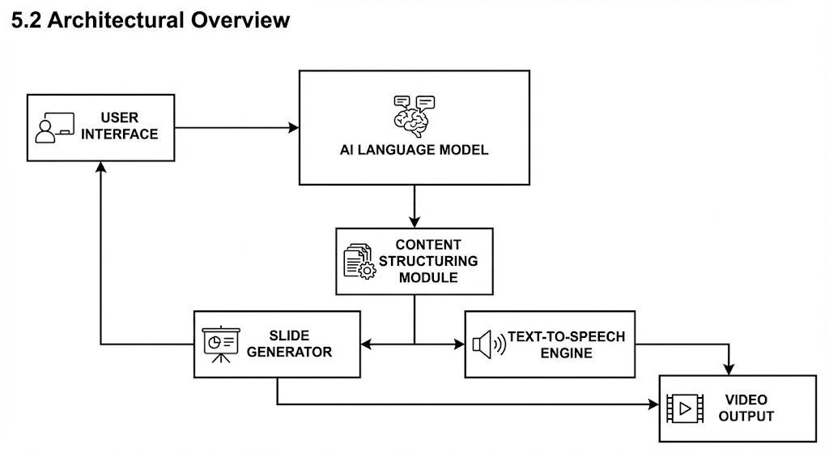

4.3 Module-Wise Design Description
4.3.1 User Input Module
This module is responsible for collecting the query or topic provided by the user. The user may be a student, teacher, or professional seeking an explanation or presentation on a particular subject.
Functions:
- Accepts text input
- Validates user query
- Forwards input to the AI processing module
Input: User query
Output: Validated text input

4.3.2 AI Response Generation Module
This module uses a Large Language Model (LLM) to generate a detailed and structured textual response based on the user’s input. The generated content forms the foundation of the presentation.
Functions:
- Sends user query to the LLM API
- Receives detailed textual response
- Ensures clarity and completeness of content
Input: User query
Output: AI-generated textual explanation

4.3.3 Content Structuring Module
The content structuring module converts the AI-generated response into a slide-friendly format. The text is divided into headings, subheadings, and bullet points suitable for PowerPoint slides.
Functions:
- Breaks content into logical sections
- Assigns titles to each slide
- Formats text into bullet points
Input: AI-generated text
Output: Structured slide content

4.3.4 PowerPoint Generation Module
This module automatically creates PowerPoint slides using the structured content. It ensures consistent formatting and readability across all slides.
Functions:
- Creates slide templates
- Inserts titles and bullet points
- Saves slides in PPT format
Input: Structured slide data
Output: Generated PowerPoint file

4.3.5 Audio Narration Module
The audio narration module converts slide content into spoken audio using Text-to-Speech (TTS) technology. This improves accessibility and supports auditory learning.
Functions:
- Converts text to speech
- Generates audio files for each slide
- Synchronizes narration length with slide content
Input: Slide text
Output: Audio narration files

4.3.6 Video Integration Module
This module merges the PowerPoint slides and corresponding audio narration into a video file. Each slide is displayed for a duration matching its narration.
Functions:
- Combines slides and audio
- Maintains synchronization
- Exports final video
Input: PPT file and audio files
Output: Video presentation file

4.3.7 Final Output Delivery Module
This module delivers the generated video presentation to the user in a downloadable or viewable format.
Functions:
- Stores output video
- Enables user access and download
Input: Video file
Output: Ready-to-use multimedia presentation

4.4 UML Diagrams (Conceptual Description)
4.4.1 Use Case Diagram
Actors:
- User (Student / Teacher / Professional)
Use Cases:
- Enter query
- Generate presentation
- View or download video output
The user interacts with the system by providing input and receiving a multimedia presentation.

4.4.2 Class Diagram (Description)
The system consists of the following major classes:
- UserInputHandler
- AIResponseGenerator
- ContentFormatter
- PPTCreator
- TTSGenerator
- VideoCreator
Each class contains methods responsible for performing its specific functionality and passing data to the next class.

4.4.3 Sequence Diagram (Description)
- User submits query
- System sends query to AI model
- AI returns text response
- Content is structured into slides
- PPT is generated
- Audio narration is created
- Slides and audio are merged into video
- Final video is delivered to user

4.5 Data Flow Diagram (DFD – Level 0 Description)
- Input: User query
- Process: AI processing, content structuring, PPT generation, audio narration, video creation
- Output: Multimedia video presentation
This flow ensures smooth transformation of user input into engaging visual and auditory output.
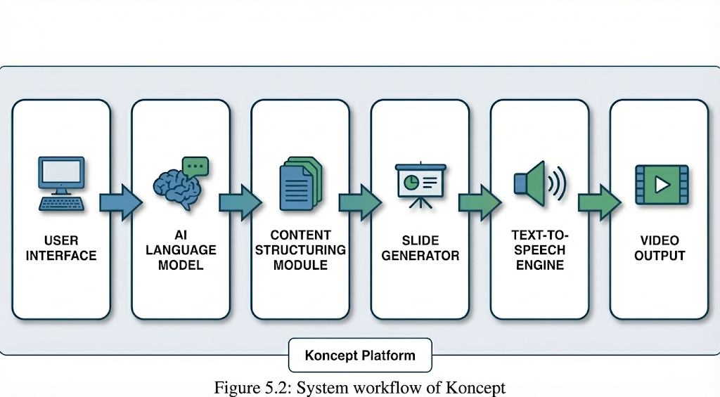

4.6 Design Advantages
- Modular and scalable architecture
- Easy maintenance and enhancement
- Supports accessibility and multimedia learning
- Reduces manual content creation effort
- Can be extended with animations, images, and multilingual support

4.7 Summary
This chapter detailed the software design of Koncept – Your Personal AI Teacher. The modular pipeline architecture enables efficient conversion of text input into multimedia video output. The design ensures clarity, flexibility, and scalability, making the system suitable for educational, professional, and accessibility-focused applications.
CHAPTER 5 : TESTING
6.1 Introduction to Testing
Testing is a critical phase in software development that ensures the system functions as expected and meets user requirements. In the Koncept – Your Personal AI Teacher project, testing was performed to verify the correctness, reliability, performance, and integration of all modules involved in generating multimedia presentations.
Since the system consists of multiple interconnected modules such as AI response generation, slide creation, audio narration, and video generation, thorough testing was essential to ensure smooth end-to-end execution.

6.2 Objectives of Testing
The primary objectives of testing in this project are:
- To verify that each module performs its intended function correctly
- To ensure accurate integration between AI, PPT, TTS, and video modules
- To validate correctness of multimedia output
- To detect and eliminate functional errors
- To ensure usability and reliability of the system

6.3 Testing Strategy
The following testing strategies were adopted:
- Unit Testing – Testing individual modules independently
- Integration Testing – Testing interaction between modules
- Black Box Testing – Validating functionality without internal code knowledge
- White Box Testing – Testing internal logic and execution paths

6.4 Black Box Testing
Black box testing focuses on validating system functionality based on input and expected output without considering internal implementation.
6.4.1 Black Box Test Cases
Test Case ID | Input Description | Expected Output | Actual Output | Result
TC-01 | Educational topic input | PPT + audio video generated | Correct video output | Pass
TC-02 | Long descriptive query | Structured slides with narration | Slides & audio synced | Pass
TC-03 | Short topic input | Auto-generated slides | Output generated | Pass
TC-04 | Professional presentation topic | Multimedia presentation | Video file created | Pass
TC-05 | User input with complex content | Clear slide breakdown | Accurate narration | Pass

6.5 White Box Testing
White box testing examines the internal structure, logic, and flow of the code. It ensures that all possible paths and conditions in the program are tested.
6.5.1 White Box Test Cases
Test Case ID | Module Tested | Condition Tested | Expected Result | Result
WB-01 | User Input Module | Input validation | Input accepted | Pass
WB-02 | AI Response Module | API response handling | Proper text generation | Pass
WB-03 | Content Structuring Module | Text segmentation | Correct slide format | Pass
WB-04 | PPT Generation Module | Slide creation logic | Slides created | Pass
WB-05 | TTS Module | Audio generation | Clear narration | Pass
WB-06 | Video Module | Audio-video sync | Proper synchronization | Pass

6.6 Integration Testing
Integration testing was conducted to ensure smooth interaction between different modules of the system.
Modules Integrated:
- AI Response Module + Content Structuring Module
- PPT Generation Module + TTS Module
- TTS Module + Video Generation Module
All integrated modules functioned correctly without runtime conflicts.

6.7 Performance Testing
Performance testing was carried out to evaluate the system’s efficiency.
Parameters Tested:
- Response generation time
- PPT creation speed
- Audio generation latency
- Video rendering time
Observation:
The system performed efficiently within acceptable time limits for educational and professional use cases.

6.8 Error Handling and Validation
- Handled empty or invalid inputs
- Managed API response delays
- Prevented slide overflow issues
- Ensured safe file generation and storage
No critical errors were observed during testing.

6.9 Testing Environment
- Platform: Google Colab
- Programming Language: Python
- Internet Connectivity: Required for AI API
- Output Formats: PPTX, MP3/WAV, MP4

6.10 Summary
This chapter presented the testing process adopted for the Koncept system. Through systematic black box and white box testing, the project was verified for functional correctness, integration reliability, and performance efficiency. All modules passed the defined test cases successfully, confirming that the system is stable, accurate, and ready for real-world usage.
CHAPTER 6: Output Screens

7.1 User Input Interface
The first output screen displays the user input interface where the user enters a query or topic. This interface is designed to be simple and user-friendly so that students, teachers, and professionals can easily interact with the system.
The user can provide any educational, technical, or professional topic as input. Once the query is submitted, it is forwarded to the Large Language Model (LLM) for response generation.
Figure 7.1: User Input Interface Screen
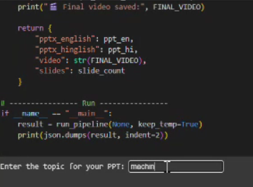

7.2 AI-Generated Text Response
After receiving the user query, the system generates a detailed textual response using an AI language model. This response forms the base content for slide creation and narration.
The generated content is structured, topic-relevant, and informative. This stage ensures that the information is accurate and logically organized before conversion into multimedia format.
Figure 7.2: AI Generated Text Output
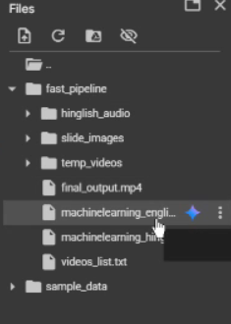
7.3 Structured Slide Content Output
In this stage, the AI-generated text is automatically converted into structured slide content. The system divides the response into slide titles and bullet points to ensure clarity and presentation quality.
Each slide represents a key concept or subtopic, making the learning content easy to understand and visually organized.

7.4 PowerPoint (PPT) Generation Output
The structured content is then converted into a PowerPoint presentation. The system automatically generates slides with appropriate titles and bullet points.
This output demonstrates the successful automation of slide creation without any manual intervention, significantly reducing the effort required for preparing presentations.

7.5 Audio Narration Output
After generating the slides, the system converts the slide content into audio narration using Text-to-Speech (TTS) technology. The narration is clear, natural, and synchronized with the corresponding slide content.
This feature enhances accessibility, especially for visually impaired users and learners who prefer auditory learning.

7.6 Video Generation Output
In the final stage, the PowerPoint slides and audio narration are merged to generate a video presentation. The resulting video plays each slide along with its corresponding narration, creating a complete multimedia learning resource.
The video output is ready for direct use in classrooms, seminars, online teaching, and professional presentations.
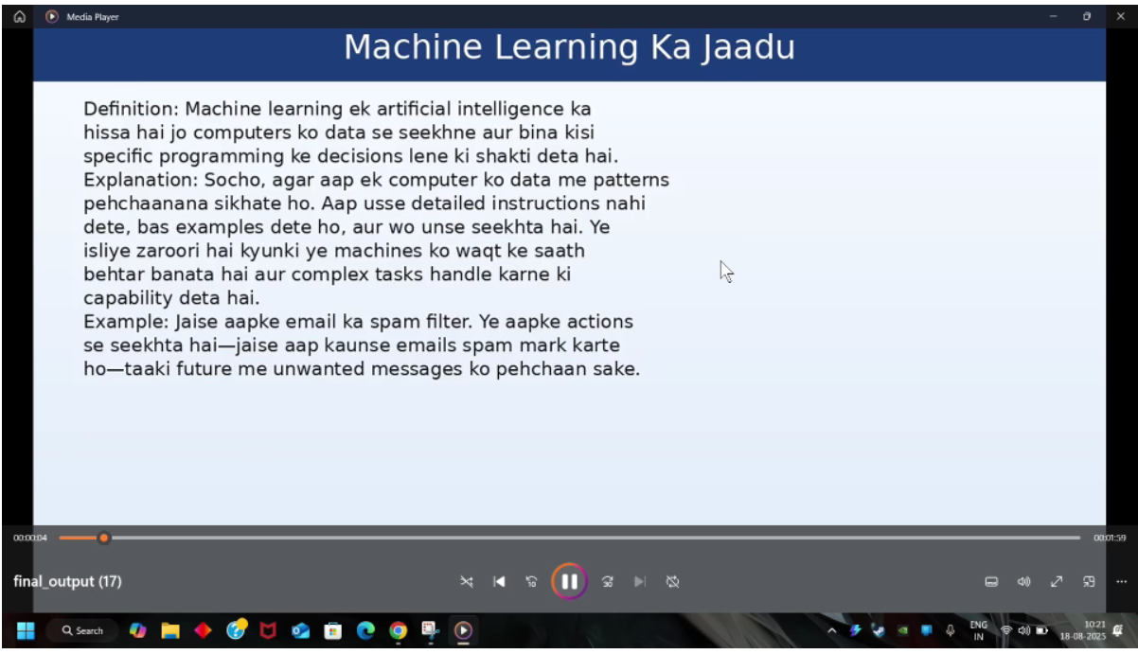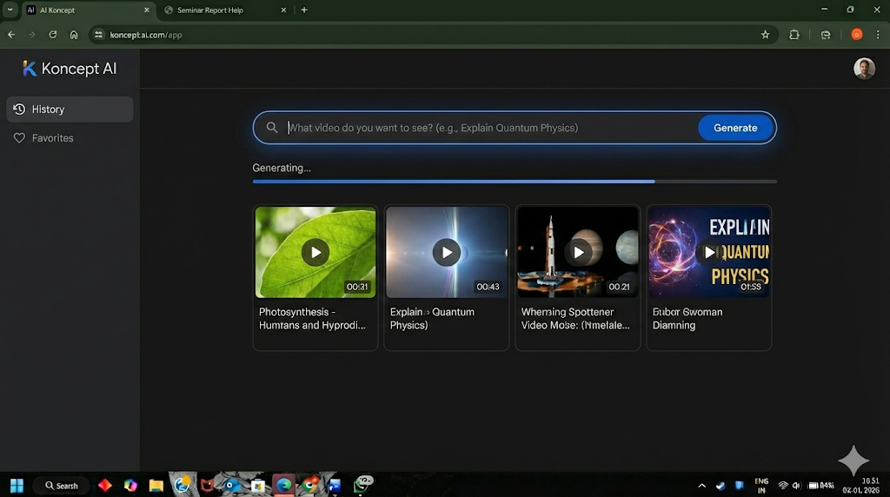

CHAPTER 8: CONCLUSION
The project titled “Koncept – Your Personal AI Teacher” successfully demonstrates the development of an AI-based system that transforms traditional text-based chatbot responses into complete multimedia presentations. The main objective of the project was to overcome the limitations of existing AI chatbots, which primarily provide only textual outputs that lack engagement, accessibility, and practical usability.
Koncept effectively integrates multiple AI technologies such as Large Language Models (LLMs), automated PowerPoint generation, and Text-to-Speech (TTS) systems to create an end-to-end pipeline. This pipeline converts user input into structured slides, generates synchronized audio narration, and produces a ready-to-use video presentation. By following multimedia learning principles, the system enhances understanding, retention, and user engagement.
The developed system significantly reduces the manual effort involved in preparing presentations, saving time for students, teachers, and professionals. It also improves accessibility by supporting auditory learning, making it beneficial for users with reading difficulties or visual impairments. The successful testing of the system in a Google Colab environment confirms its feasibility, reliability, and practical usability.
Overall, Koncept bridges the gap between text-only AI systems and real-world multimedia content requirements. The project demonstrates strong potential in educational, professional, and assistive technology domains, proving that AI-driven multimedia generation can play a crucial role in modern digital learning and communication environments.

CHAPTER 9: FUTURE ENHANCEMENTS AND RECOMMENDATIONS
Although Koncept successfully achieves its intended objectives, there is significant scope for future enhancements to further improve its functionality and impact. Some of the possible future enhancements are as follows:
- Multilingual Support
The system can be extended to generate slides and audio narration in multiple languages. This would allow Koncept to reach a wider global audience and support regional language learners.
- Animated and Visually Rich Slides
Future versions can include animations, transitions, images, icons, and diagrams to make presentations more visually appealing and interactive.
- Interactive Presentations
Features such as quizzes, clickable elements, and interactive question-answer sections can be integrated into the generated presentations to improve learner engagement.
- Cloud-Based Web Application
Koncept can be deployed as a fully functional web application, allowing users to access the system from anywhere without requiring a local setup.
- Customization Options
Users can be given options to choose presentation themes, narration voice styles, slide length, and content depth according to their preferences.
- Real-Time Classroom Integration
The system can be enhanced to support live classroom usage, where teachers can generate presentations instantly during lectures.

REFERENCES
[1] R. E. Mayer, Multimedia Learning, 2nd ed. Cambridge, U.K.: Cambridge University Press, 2009.
[2] T. Stelzer, G. Gladding, J. Mestre, and D. Brookes, “Comparing the efficacy of multimedia modules with traditional textbooks for learning introductory physics content,” American Journal of Physics, vol. 77, no. 2, pp. 184–190, Feb. 2009.
[3] CAST, Universal Design for Learning Guidelines Version 2.2. Wakefield, MA, USA: Center for Applied Special Technology, 2018. [Online]. Available: https://udlguidelines.cast.org
[4] D. Wood, J. Moxley, K. Tighe, and T. Wagner, “Does use of text-to-speech software improve reading comprehension for students with reading difficulties?” Journal of Learning Disabilities, vol. 51, no. 1, pp. 73–84, Jan. 2018.
[5] A. Vaswani et al., “Attention is all you need,” in Proc. Advances in Neural Information Processing Systems (NeurIPS), 2017, pp. 5998–6008.
